User Manual For Softwares of RAXAR

- Fill out the registration form with all the details and click submit button at the end of the form
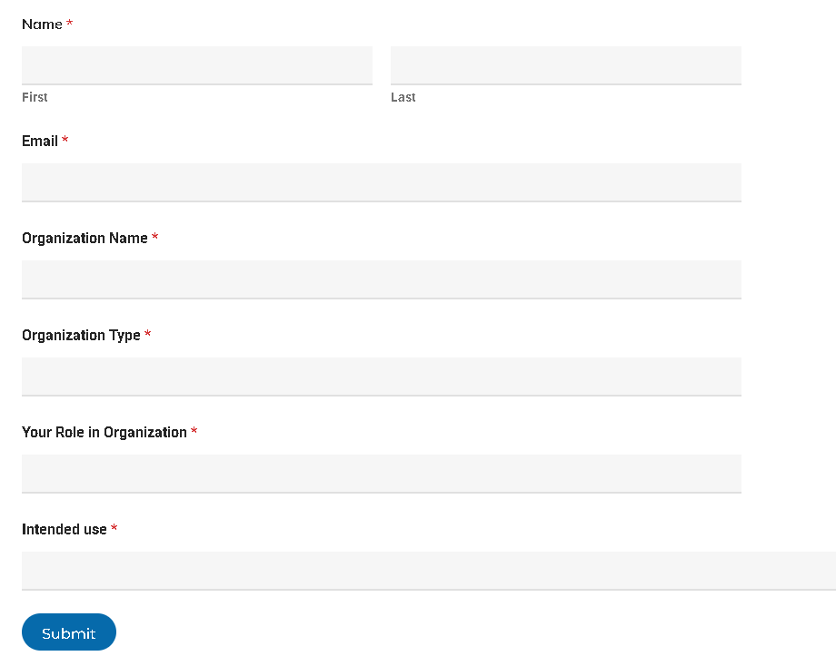.
- After clicking submit button on the form you will be redirected to our website to try out our softwares on your input data.
Click on the application to select the application which you want to use.
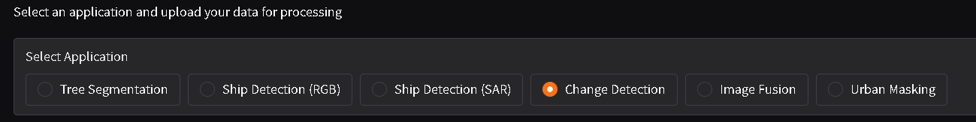
- Upload your input files according to each application and then click on Run button.
Make sure the size of any of the image is not more than 2048x2048
- Wait for few seconds and then you can download your output file.

Tree Segmentation.
- Select Tree segmentation among the application choices.
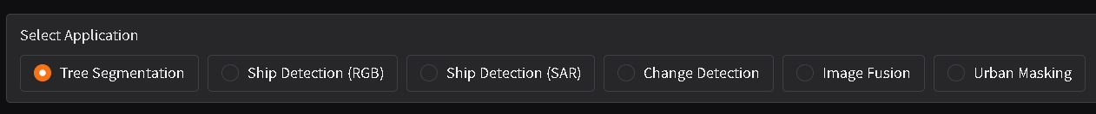
- Create your multiband input file with image size for each band less than 2048x2048 with bands in following order
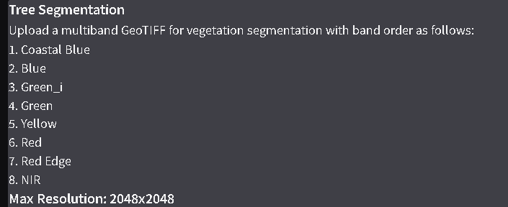
- Upload your input tif image in input geotif area. You can either select your file from file location or just drag and drop your input file.
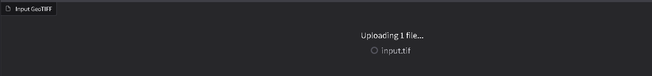
- Click on the “Run Tree Segmentation” button and wait for a few seconds for application to process your image.

- After processing is complete you can download the results from Download Results sections and then view the output file.
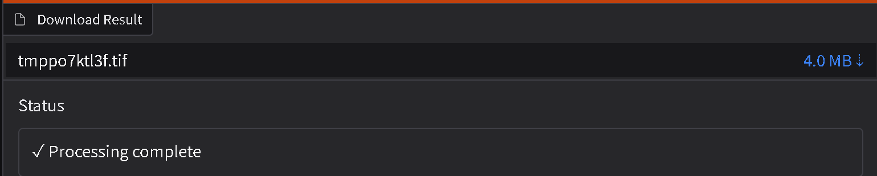

Ship Detection (RGB)
- Select Ship Detection(RGB) among the application choices
- Create your single band tif images for all the 3 bands; Red, Green and Blue.
Note that the size of each image should not be more that 2048x2048 and size of each file should be less than 25mb
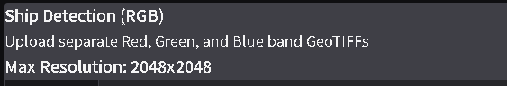
- Upload your input tif images of Red band, Green band and Blue band in their respective area. You can either select your file from file location or just drag and drop your input file.
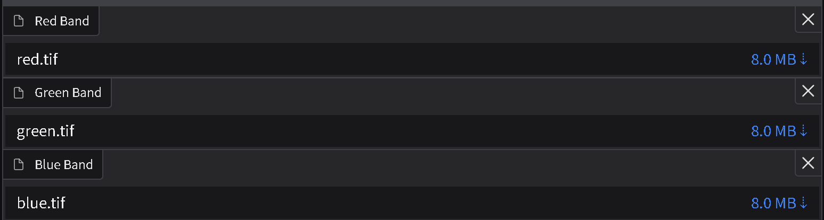
- Click on “Run Ship Detection” button and wait for a few seconds for the application to process your images.

- After processing is complete you can download the results from Download Results sections and then view the output file.

Ship Detection (SAR)
- Select Ship Detection (SAR) among the application choices.
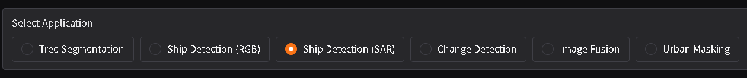
- Create your multiband tif image with band order VH and VV and image size of each band less than 2048x2048 and file size of input tif image to be less than 50 mb
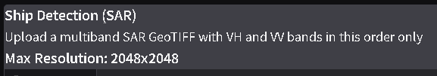
- Upload your input tif image in SAR GeoTIFF area. You can either select your file from file location or just drag and drop your input file.
- Click on “Run Ship Detection” button and wait for a few seconds for the application to process your image.

- After processing is complete you can download the results from Download Results sections and then view the output file. The downloaded result will be a zip file which contains the tif file for the masks of the ships, geojson file marking the boundaries of the ship and an png image for reference.
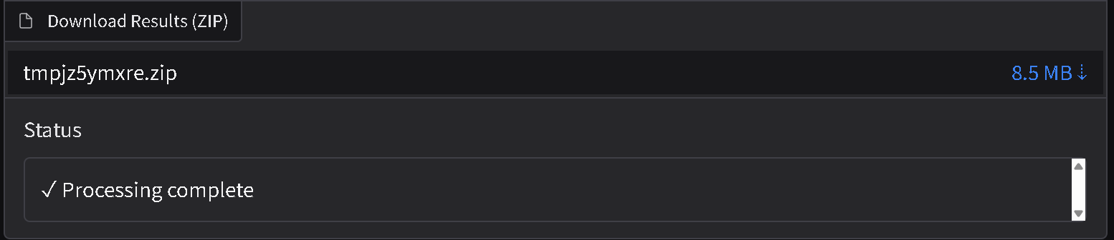

Change Detection
- Select Change Detection among the application choices
- Create your 2 single band sar tif image of before and after time for either vv or vh bands. Image size of each band should be less than 2048x2048 and file size of tif image to be less than 25mb
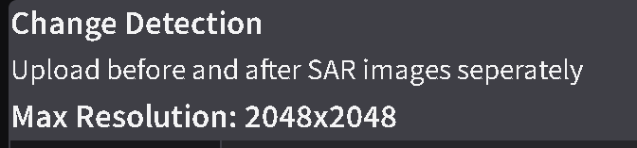
- Upload your before and after image in their respective area. You can either select your file from file location or just drag and drop your input file.
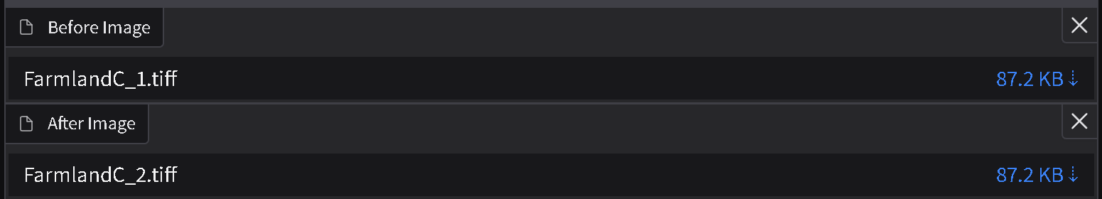
- Click on “Change Detection” button and wait for a few seconds for the application to process your image.

- After processing is complete you can download the results from Download Results sections and then view the output file.
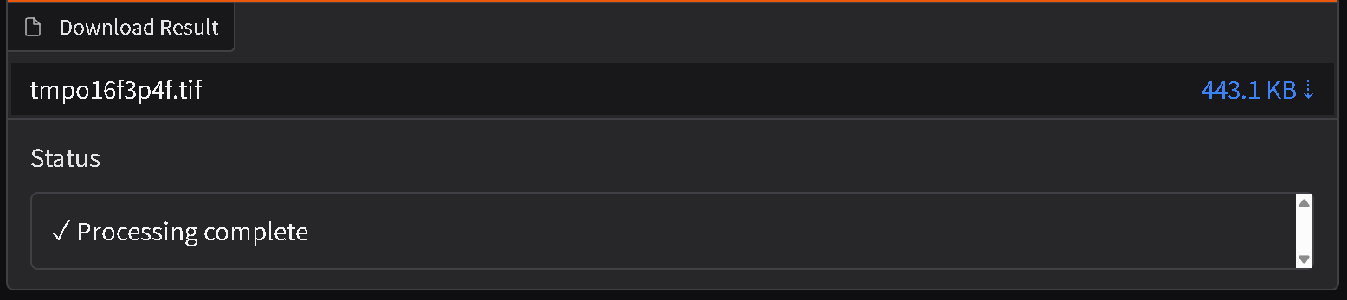

Image Fusion
- Select Image Fusion among the application choices.
- Create your 2 different tif images, 1 for optical band and other for sar band. Image size of each band should be less than 2048x2048 and file size of tif image to be less than 25mb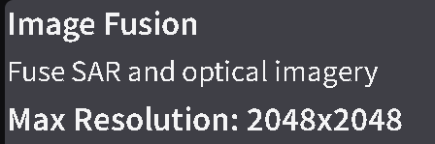
- Upload your sar band and optical band image in their respective area. You can either select your file from file location or just drag and drop your input file.
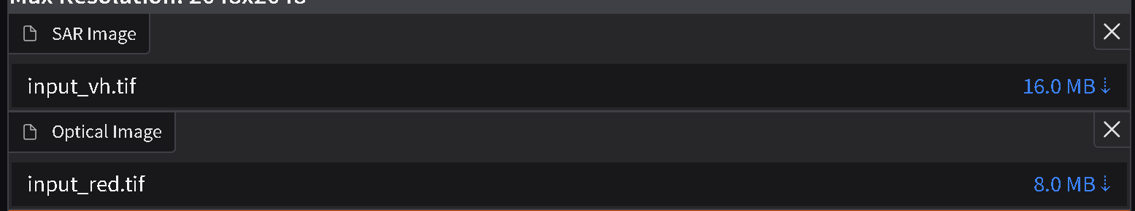
- Click on “Run Image Fusion” button and wait for a few seconds for the application to process your image.

- After processing is complete you can download the results from Download Results sections and then view the output file.
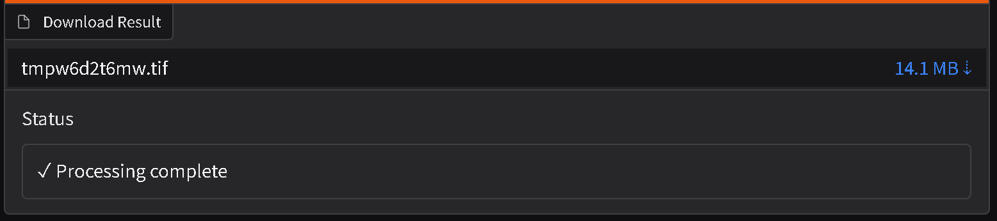

Urban Masking
- Select Urban Masking among the application choices
- Create your 10 different images as shown in the image below. Image size of each band should be less than 2048x2048 and file size of tif image to be less than 25mb
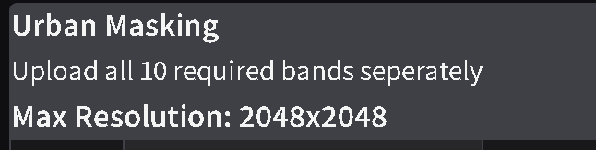
- Upload all the images in their respective areas. You can either select your file from file location or just drag and drop your input file.
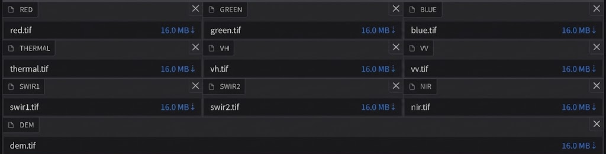
- Click on “Run Urban Masking” button and wait for a few seconds for the application to process your image.

- After processing is complete you can download the results from Download Results sections and then view the output file.

